Lab Assignment 7-uart

# Masauso Lungu 209533

## 1. Preparation tasks

**Table with voltage divider, calculated, and measured ADC values for all buttons.**

| **Push button** | **PC0[A0] voltage** | **ADC value (calculated)** | **ADC value (measured)** |
| --- | --- | --- | --- |
| Right | 0 V | 0 | 0 |
| Up | 0.495 V | 101 | 101 |
| Down | 1.202 V | 246 | 245 |
| Left | 1.97 V | 403 | 402 |
| Select | 3.18 V | 651 | 650 |
| none | 5 V | 1023 | 1022 |

## 2. ADC:

**a) Listing of ADC_vect interrupt routine with complete code for sending data to the LCD/UART and identification of the pressed button.**

/* -------------------------------------------------------------------*/

/**

* ISR starts when ADC complets the conversion. Display value on LCD

* and send it to UART.

*/

ISR(ADC_vect)

{

*uint16_t* value = 0;

char lcd_string[8];

value = ADC; // Copy ADC result to 16-bit variable

// Convert to string in decimal

*itoa*(value, lcd_string, 10);

lcd_gotoxy(7,0);

lcd_puts(" ");

lcd_gotoxy(7,0);

lcd_puts(lcd_string);

// Send data through UART

if (value < 700)

{

uart_puts("ADC value in decimal: ");

uart_puts(lcd_string);

uart_puts("\r\n"); // put cursor to beginning of current line or next line

}

// Convert to string in hex

*itoa*(value, lcd_string, 16);

lcd_gotoxy(13,0);

lcd_puts(" ");

lcd_gotoxy(13,0);

lcd_puts(lcd_string);

//Displaying the identity of the button pressed

if(value >= 1016)

{

lcd_gotoxy(7, 1);

lcd_puts(" ");

lcd_gotoxy(7, 1);

lcd_puts("None");

}

else if(value == 0)

{

lcd_gotoxy(7, 1);

lcd_puts(" ");

lcd_gotoxy(7, 1);

lcd_puts("Right");

}

else if(value == 101)

{

lcd_gotoxy(7, 1);

lcd_puts(" ");

lcd_gotoxy(7, 1);

lcd_puts("Up");

}

else if(value == 245 )

{

lcd_gotoxy(7, 1);

lcd_puts(" ");

lcd_gotoxy(7, 1);

lcd_puts("Down");

}

else if(value == 402)

{

lcd_gotoxy(7, 1);

lcd_puts(" ");

lcd_gotoxy(7, 1);

lcd_puts("Left");

}

else if(value == 650)

{

lcd_gotoxy(7, 1);

lcd_puts(" ");

lcd_gotoxy(7, 1);

lcd_puts("Select");

}

}

**b) Screenshot of SimulIDE circuit when "Power Circuit" is applied**.

## 3. UART

**a) (Hand-drawn) picture of UART signal when transmitting data DE2 in 4800 7O2 mode (7 data bits, odd parity, 2 stop bits, 4800 Bd),**

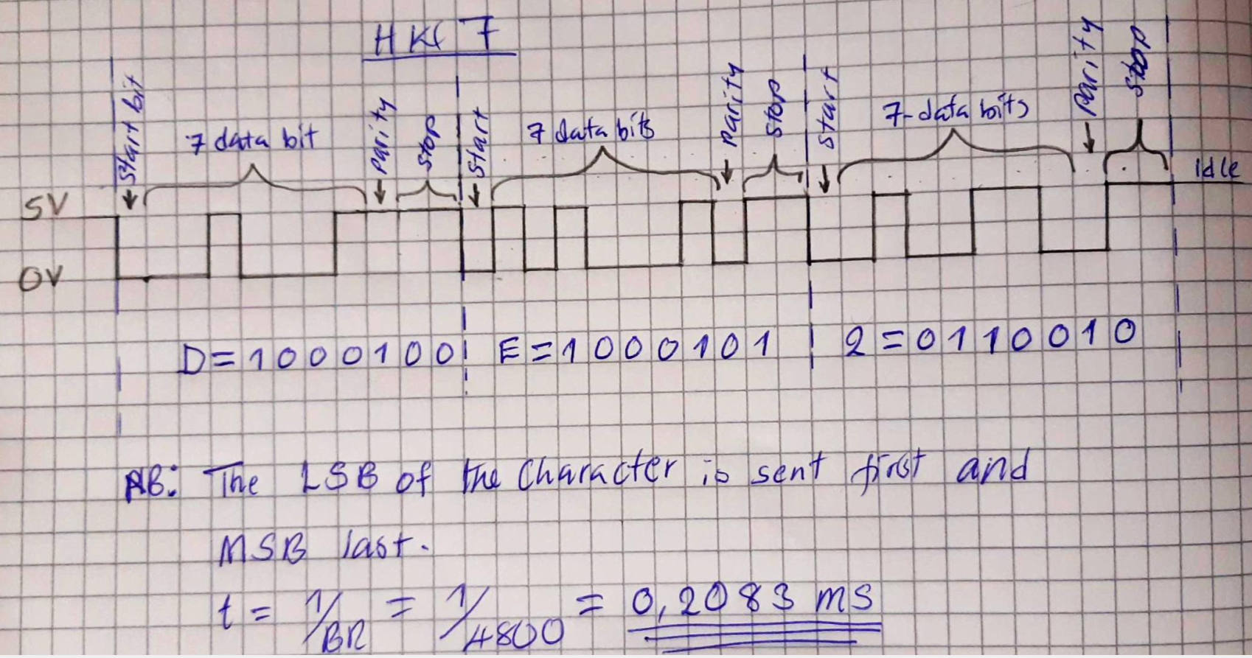

**b)** **Listing of code for calculating/displaying parity bit.**

//Parity bit evaluation (odd parity)

if(value %2==0)

{

lcd_gotoxy(14,1);

lcd_putc('1');

}

else

{

lcd_gotoxy(14,1);

lcd_putc('0');

}

## Link to github repository

https://github.com/Masauso-L/Digital-electronics-2/tree/master/Labs/07-uart